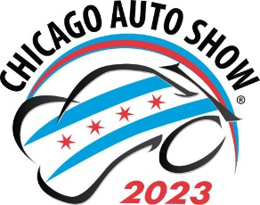

SCHOOL GROUP TICKET RESERVATION-2023
(Payment upon arrival)

Please complete the following: (Incomplete reservations will not be accepted)

Name of School

Contact Name

Address

City State ZIP

( )
Contact Telephone Email Address (All confirmations & information will be via email)

Day/Date of visit (CIRCLE ONE): Mon. 2/13 Tues. 2/14 Wed. 2/15 Thurs. 2/16 Fri. 2/17 Mon. 2/20
Estimated number of student tickets needed: ______ @_$11.20 each =Ticket Cost_______________
Ticket Cost + Credit Card Fee (if applicable) =Total Due___________________
(20 ticket minimum to obtain group rates, $11.20 each including City of Chicago & Cook County Amusement Tax)
Number of complimentary chaperone tickets: (1:10 ratio)
Payment type (Circle one) organization’s check credit card

Reserved tickets purchased on the day you attend are only good for that day and are not refundable!!!
Send/make check payable to:
Chicago Automobile Trade Association
18W200 Butterfield Rd. - Oakbrook Terrace, IL 60181-4810
630-495-2282 (tel) rsammarco@drivechicago.com (e-mail)

