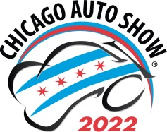

SCHOOL GROUP TICKET RESERVATION-2022
(Payment upon arrival)

Please complete the following: (Incomplete reservations will not be accepted)

Name of School

Contact Name

Address

City State ZIP

( )
Contact Telephone Email Address (All confirmations & information will be via email)

Day/Date of visit (CIRCLE ONE): Mon. 2/14 Tues. 2/15 Wed. 2/16 Thurs. 2/17 Fri. 2/18 Mon. 2/21
Estimated number of student tickets needed: (20 ticket minimum to obtain group rates, $10 each)
Number of complimentary chaperone tickets: (1:10 ratio)
Number of lunch coupons: (do NOT collect money in advance)
Payment type (Circle one) cash organization’s check credit card

Reserved tickets purchased on the day you attend are only good for that day and are not refundable!!!
Send/make check payable to:
Chicago Automobile Trade Association
18W200 Butterfield Rd. - Oakbrook Terrace, IL 60181-4810
630-495-2282 (tel) rsammarco@drivechicago.com (e-mail)

