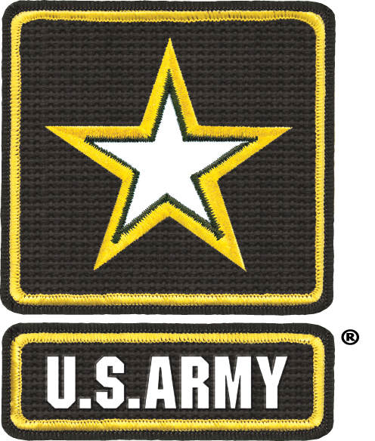 | Press Release  U.S. Army Recruiting Battalion – Chicago  3202 Mississippi Street Bldg 3215  Great Lakes, Illinois 60088

By Mike Scheck
Public Affairs Specialist
Chicago Army Recruiting Battalion

Chicago Army Recruiting Battalion keeps local tradition
alive with its Chicago 2012 Auto Show participation

CHICAGO, Ill. - The Chicago Army Recruiting Battalion will, for the sixth year in a row, bring the Army Strong message to the 2012 Chicago Auto Show. The Chicago Auto Show runs from Friday, Feb. 10 through Sunday, Feb. 19.
The Chicago Battalion Auto Show exhibit continues its interactive theme with the introduction of the Science, Technology, Engineering and Math (STEM) van. According to the Army Recruiting Exhibit Branch, the van is designed to “effectively communicate the total Army story of options, opportunities, leadership and education; increase positive brand perception by showcasing hi-tech training and career opportunities available within the Army.”
The STEM experience is broken down into three parts. PART I: Prospects will enter the STEM asset in groups of four. Prospects will register on “goarmy.com” (email address and pass code provided by recruiter) to enter to win a PPI via weekly random drawing. Upon entering the experience, prospects are surrounded by flat panel displays showing fictional news clips from around the world that will catch the prospect up from the current day to 2045 (intent is to break association with current conflict). All screens converge to show the final clip, in which prospects are informed of the latest crisis- an attack on a power plant in Eastern Europe.
PART II: In the second part of the STEM asset experience, prospects receive a mission briefing from a total Army team, during which they are informed that the U.S. Army has been called in to assist the EU in this most crisis, and that their skill sets are needed to mitigate the situation. Prospects will receive a mission overview brief from the Officer in charge, a field report from the Non-commissioned officer and detailed instructions on how to complete the interactive technology exercise (Part III) by the DAC. The intent of this aspect of the experience is to immerse prospects in the roles of the various Army missions while showcasing the teamwork that is critical to Soldier success. This aspect also showcases the Army multicultural mission through the selection of Soldiers and actors.
PART III: In the final part of the STEM experience, prospects will leverage one of four touch screen stations to assemble a unique, virtual, 3D technology solution from a menu (Unmanned Aerial Vehicle, Autonomous System, Future Concept Vehicle, Mobile Base Shelter, etc.). At the conclusion of their experience, a final filmed “news clip” will play, highlighting how the prospect’s unique technology solution aided in mitigating the crisis situation.
The Chicago Battalion Army booth ventures from the future to the past with its exhibit of the Gen. George S. Patton staff car. The 1938 Series 75 Cadillac was the car Patton was riding in that subsequently crashed into an Army truck on Dec. 9, 1945 in Germany shortly after the end of WWII. Patton sustained injuries in the accident that left him paralyzed. He died on Dec. 21, 1945 of a pulmonary embolism as a direct result of the accident.

The Patton Accident
On Sunday, 9 December 1945, General Patton planned a visit to some ruins and a hunting trip before returning to the United States the next day. With him in the sedan were Major General Hobart Gay, his Chief of Staff when he commanded the Third Army, and Private First Class Horace Woodring, his driver. The sedan passed two Military Police Lieutenants, Peter K. Babalas and John Metzker. At 11:30 AM the car struck a 2 ½ ton truck driven by T/5 Robert L. Thompson. The two Military Police officers arrived on the scene “before the dust had settled.”
Lt. Babalas assumed command of the situation. He saw that only Patton was injured. Patton sat on the edge of the back seat and flew forward on impact. He suffered bloody but superficial lacerations to the scalp when his head hit the clock mounted in the rear of the front seat. Lt. Babalas, concerned about the position of Patton’s head, ordered him sent directly to the hospital at Heidelberg. There doctors determined that Patton had a broken neck and was paralyzed from the neck down.
Babalas’ initial report of the accident was that the damage to both vehicles was minor. Babalas decided that he would report negligence on the part of both drivers. He believed Woodring was speeding and Thompson turned in front of a moving vehicle. However, when he visited Patton in the hospital, Patton requested that he find neither driver at fault. Patton relieved both drivers of any responsibility.

An old friend returns to the Auto Show in the form of the Stryker armored four-wheel-drive fighting vehicle. This makes it the fourth year-in-a-row for the Stryker in the Army booth. The Stryker was designed as a medium based armored vehicle, used to move infantry to urban battlefields quickly. The vehicle’s main reliance in battle is speed and communications.
Auto Show guest will be able to test their New Year’s resolution strength in the Army Strong challenge again this year, with the return of the traveling Drill Sergeants.
Also on hand for this year’s Auto Show is the U.S. Army Entertainment Team. The pop/top 40s group will be performing shows on the Army Strong stage through the first weekend of the show.

Follow the Chicago Army Recruiting Battalion on facebook @ http://www.facebook.com/ArmyRecruitingBnChicago

And on Twitter @ warriorapa

MEDIA CONTACT:
Mike Scheck is a public affairs specialist with the U.S. Army Chicago Recruiting Battalion. Mike Scheck can be reached at (224) 538-3530 or by e-mail at Michael.scheck@usarec.army.mil.

